Nepal College of Information Technology
Unit Test
Spring 2010
Program : BE IT Time : 2 hrs
Semester : Spring (II) FM : 63
Subject : Electronic Devices PM :

- Candidates are requested to give their answer as far as practicable in their own words.
- The figure in the margin indicates the full marks
- Attempt ALL question
1. a) With the necessary sketch explain the characteristics of P-N junction diode under forward and reverse biased condition. 7
b) A silicon PN junction is formed from P material doped with 10²² accepters/m³ and N material doped with 1.2×10²¹ donors/m³. Find the Thermal voltage and barrier voltage at 25⁰C. (Given: n_{i}=1.5×10¹⁶, K= 1.38×10⁻²³ J/K, and q= 1.6×10⁻¹⁹ coulombs) 8

2. a) . Differentiate between transition and diffusion capacitance. 8
b) Explain the breakdown phenomenon of P-N junction. Distinguish Zener and Avalanche breakdown. 7
3. a) Discuss the construction, characteristics and applications of Zener diode 8
b) Explain the basic characteristics of CE configuration of transistor. 7
4. a) Transistor can be used as a switch. Explain it. 8
OR
Determine the dc bias voltage V_{CE} and current I_{C} for the voltage divider configuration shown in figure below.
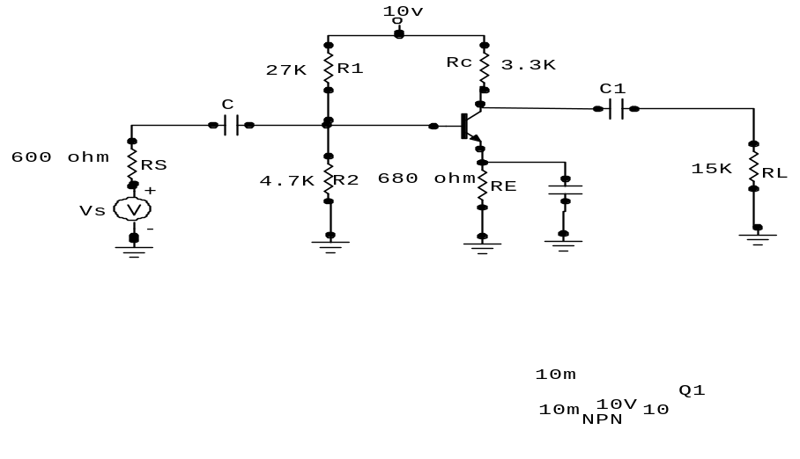
5. Write shorts notes on: (Any Two) 5*2=10
a) Thermal Runway
b) Schottky Diode
c) Stability factor.

